EXPERIMENT-09 DHILIPAN M
22/07/2026 192411038

TRAVELLING SALESMAN PROBLEM (TSP) USING THE BRUTE FORCE
AIM:
To write a Python program to solve the Travelling Salesman Problem (TSP) using the Brute Force approach.
ALGORITHM:
Step 1: Represent the cities and the distance matrix.
Step 2: Select the starting city.
Step 3: Generate all possible permutations of the remaining cities.
Step 4: Calculate the total travel cost for each possible route.
Step 5: Compare all route costs and identify the route with the minimum cost.
Step 6: Display the optimal path and the minimum travel cost.
PROGRAM:
from itertools import permutations
graph = [
[0, 10, 15, 20],
[10, 0, 35, 25],
[15, 35, 0, 30],
[20, 25, 30, 0]
]
cities = [0, 1, 2, 3]
start = 0
min_cost = float('inf')
best_path = []
for path in permutations(cities[1:]):
current_cost = 0
current = start
for city in path:
current_cost += graph[current][city]
current = city
current_cost += graph[current][start]
if current_cost < min_cost:
min_cost = current_cost
best_path = [start] + list(path) + [start]
print("Optimal Path:", best_path)
print("Minimum Cost:", min_cost)

OUTPUT:
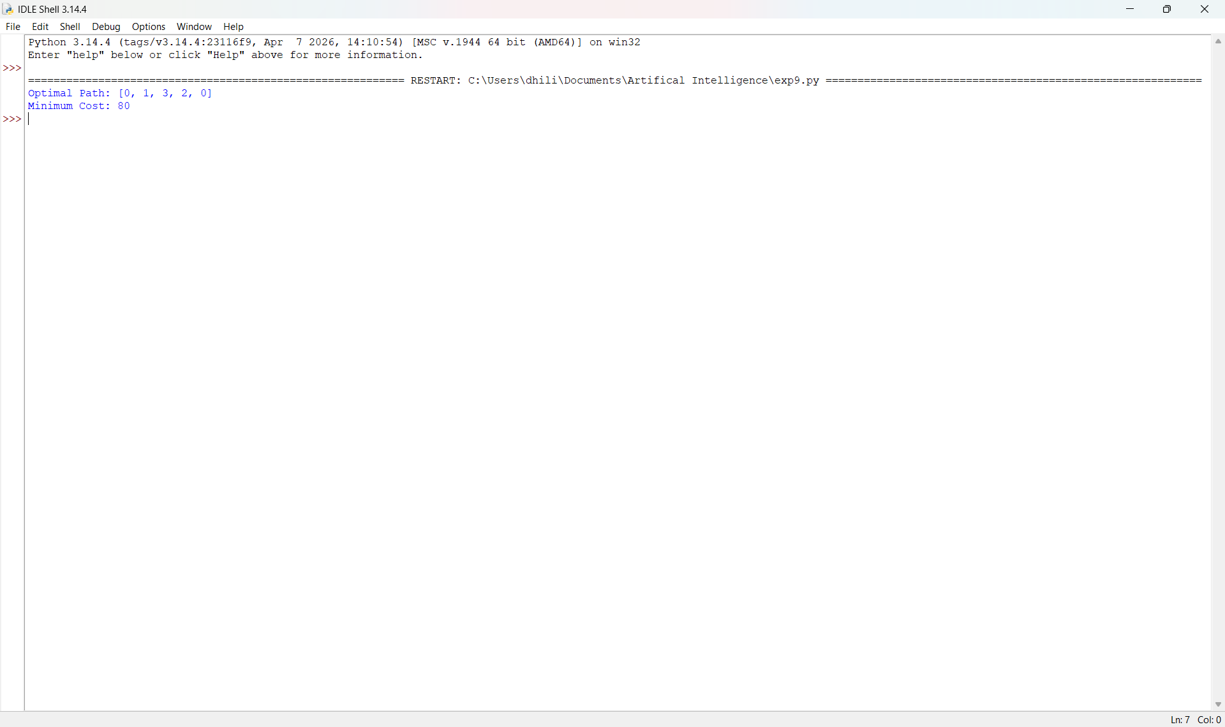

RESULT:
Thus, the Python program to solve the Travelling Salesman Problem (TSP) using the Brute Force approach was implemented successfully and the required output was obtained.

